MySQL Date & Time Formats – With Queries and Examples

1. DAY Formats with Query & Example
Format Codes:
%W – Full weekday name (e.g., Monday)
%a – Short weekday name (e.g., Mon)
%w – Day number (0=Sunday)
%d – Day of month (01–31)
%e – Day of month (1–31)
%D – Day with suffix (e.g., 7th)

Example Query:
SELECT
DOB,
DATE_FORMAT(DOB, '%W') AS Full_Day,
DATE_FORMAT(DOB, '%a') AS Short_Day,
DATE_FORMAT(DOB, '%d') AS Day_2Digit,
DATE_FORMAT(DOB, '%D') AS Day_With_Suffix
FROM Sales;

2. MONTH Formats with Query & Example
Format Codes:
%M – Full month name (December)
%b – Short month name (Dec)
%m – Month number (12)

Example Query:
SELECT
DOB,
DATE_FORMAT(DOB, '%M') AS Full_Month,
DATE_FORMAT(DOB, '%b') AS Short_Month,
DATE_FORMAT(DOB, '%m') AS Month_Number
FROM Sales;

3. YEAR Formats with Query & Example
Format Codes:
%Y – 4-digit year (1990)
%y – 2-digit year (90)

Example Query:
SELECT
DOB,
DATE_FORMAT(DOB, '%Y') AS Year4,
DATE_FORMAT(DOB, '%y') AS Year2
FROM Sales;

4. TIME Formats with Query & Example
Format Codes:
%H – Hour (24-hour)
%h – Hour (12-hour)
%i – Minutes
%s – Seconds
%p – AM/PM

Example Query:
SELECT
LoginTime,
DATE_FORMAT(LoginTime, '%H:%i:%s') AS Time24,
DATE_FORMAT(LoginTime, '%h:%i:%s %p') AS Time12
FROM EmployeeLog;

Practical Example – December Birthdays
Display Salesmen born in December with day name:
SELECT SalesName,
DATE_FORMAT(DOB, '%W') AS DayName,
DOB
FROM Sales
WHERE MONTH(DOB) = 12;

LAB PROGRAM
4. Create Sales table with the following fields( Sales No, Sales name, Branch, Sales amount, DOB)
- Insert five records
- Calculate total Sales amount in each branch
- Calculate average Sales amount in each branch
- Display all the salesmen, DOB who are born in the month of December as day in character format.
Creating the table
create table sales(sales_no int primary key,sales_name varchar(50),branch varchar(50),sales_amount decimal(10,2),dob date);

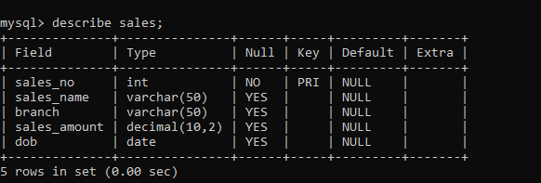

- Inserting tuples

insert into sales values (1,'alice','New York',5000.00,'1990-12-15');
insert into sales values (2,'Bob','Las Vegas',3000.00,'1985-12-15');
insert into sales values (3,'Charlie','Chicago',7000.00,'1995-11-17');
insert into sales values (4,'David','New York',6000.00,'1995-03-17');
insert into sales values (5,'Tia','LA',4000.00,'2002-03-17');
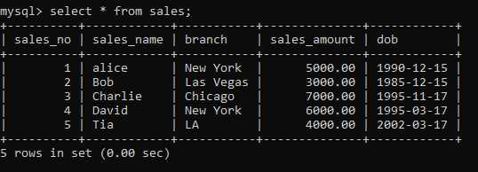
- select branch,sum(sales_amount) as total_sales_amount from sales group by branch;

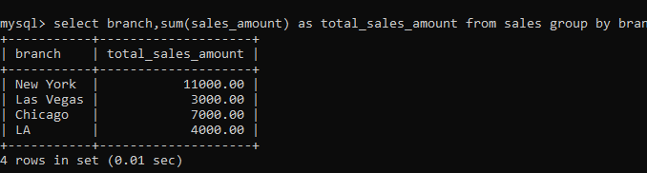

- select branch,avg(sales_amount) as average_sales_amount from sales group by branch;

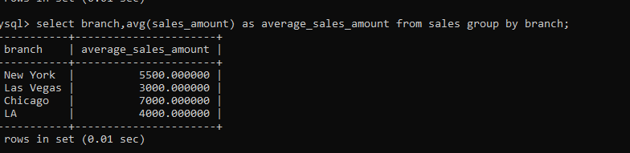

- select sales_name, date_format(dob, '%w %d %m %y') as Birth_Day from sales where month(dob) = 12;

